
Nanfang Communication

 Digital Microwave Network Transmitting Equipment
Technical Manual

Guilin Nanfang Communication Device Engineering Corporation
Address: Liuhe Road 125, Guilin
Post: 541004
Tel: 0773-5818588/5830541
Fax: 0773-5830540
E-Mail: glnftx125@yahoo.cn

Contents

1. | Introduction ……………………………………………….. | 2
2. | Features ……………………………………………………. | 2
3. | Specification ……………………………………………….. | 3
4. | System configuration and Principle ……………………….. | 5
4.1 | System configuration………………………………………. | 6
4.2 | chart ……………………………………………………….. | 7
4.3 | Principle …………………………………………………… | 8
5. | Applications ……………………………………………….. | 9
5.1 | Design Consideration ……………………………………... | 9
5.2 | Major customer areas……………………………………… | 10
5.3 | General Applications………………………………………. | 10
5.4 | Specific Applications……………………………………… | 11
5.5 | Application Cases…………………………………………. | 12

1. Introduction

It’s a kind of integrated digital radio communication method making use of small-medium capacity, compact digital microwave recently, developing with the fast growth of wireless access, mobile communication and integrating RF microwave technology and digital modulation, computer-controlled technology etc.. In order to satisfy increasing demand of digital transmission, GuiLin NanFang Communication Equipment Company develops the third generation low cost, high reliability digital microwave system-Smart based on long term experience of manufacturing digital microwave equipments. It’s a point-to-point narrow-band digital microwave relay system, provide reliable digital microwave relay access line. It’s stable, compact and light, features fast installation, smart network configurations, suitable for complication terrain and is used widely in post and telecommunication, electrical power, martial, rural lines and various private networks, especially in inter-connection between BTS of mobile network and network link in enterprises and colleges. And it’s also used for temporary and emergency communication because of fast installation.

Smart Digital radio equipment is composed of high-performance antenna, outdoor unit (ODU) and indoor unit (IDU) and system cables, transmitted in 7-18GHz band, provides a transmission capacity of two, four, eight and sixteen E1 signals or one E3 signal, plus additional service channels and supervisory channels. When the radio frequency is crowed and urgent construction of network, Smart digital microwave equipment can form an end-to-end reliable network in wireless link.

This brochure covers Smart series digital microwave equipments, including 7/8/11/13/15/18GHz, 2×E1/4×E1/ 8×E1/16×E1/1×E3 provided by GuiLin NanFang Communication Equipment Company.

2. Features
- Advanced MIC, HIC and VLSI Technologies and digitalized QPSK modem technology
- Forward Error Correction
- Digital Bandwidth Limiting
- High performance LNA-MIX, supreme receiver sensitivity, allowing small antenna
- Power amplifier gain-controlled technology and TX power adjustable by step
- Field tunable local oscillator, changing RF point frequency without measuring equipment or changing modules, smart and fast network
- Various interfaces, used for different services
- Compact and fast installation. Only one cable between ODU and IDU. Automatically equalization. Maximum length up to 300m
- Two RS-232C data channels, data up to 32kbps, async.
- System flexibility, IDU is used commonly for 7-18GHz;and ODU for 2×E1/4×E1/8×E1/16×E1/1×E3
Local and remote supervision function on IDU, near end baseband loopback and far end baseband loopback, status monitored by PC. Pre-settable BER alarm point, easy and simple maintenance.

3．Specification
3.1 Frequency band: 7/8/13/15/18GHz
3.2 TX power: + 27 dBm /25 dBm /20 dBm /17 dBm,
(option)
3.3 Frequency source: Phase-locked combiner
3.4 Frequency stability: ±10ppm
3.5 Noise figure of receiver: ≤ 4.5dB (7/8G)
≤ 6dB (11/13/15/18G)
3.6 Tunable channels: Settable by PC through RS-232 interface
3.7 TX power control: Settable by PC through RS-232 interface
3.8 IF frequency: TX 310 MHz；RX 70 MHz
3.9 Modulation: QPSK Quadra-Phase Shift Key
3.10 Data capacity: 2×E1 4×E1 8×E1
16×E1 1×E3
3.11 Channel bandwidth: 2×E1: 3.5 MHz
4×E1: 7.0 MHz
8×E1: 14 MHz
16×E1: 28 MHz
1×E3: 28 MHz
3.12 Connection between IDU and ODU:
Distance: Max. 300m；one coaxial cable,8DFB or equivalent
Connector: N-N type, male

3.13 Receiver threshold

BER | Frequency band | Level
BER | Frequency band | 2.048 Mbit/s | 8.448 Mbit/s | 34.368 Mbit/s
1×10⁻³ | 7/8 GHz | -94 dBm | -91 dBm | -85 dBm
1×10⁻³ | 11/13/15/18 GHz | -93 dBm | -90 dBm | -84 dBm
1×10⁻⁶ | 7/8 GHz | -92 dBm | -89 dBm | -83 dBm
1×10⁻⁶ | 11/13/15/18 GHz | -91 dBm | -88 dBm | -82 dBm
Note:test in the port of antenna.

3.14 Data interface:
Type: Conform to ITU-T G.703（E1）
Input/output: 75 ohms, unbalanced（BNC）
3.15 Code: HDB3
3.16 Loop-back test: near end and far end baseband loopback
3.17 Service channels:
Digital SC 2-wire telephone, interface: RJ-11
Auxiliary data channels 2 channels, bit rate: 0 ~ 32 kbps
Protocol: RS-232C
Interface: DB9
SV data channels bit rate: 19.2 kbps
Protocol: RS-232C/RS-485
Interface: DB9/DB15
3.18 Working environment:
Temperature: IDU: 0℃ ~ +45℃ （guarantee）
-5℃ ~ +50℃ （working）
ODU: -30℃ ~ +55℃ （guarantee）
-35℃ ~ +60℃ （working）
Relative humidity: IDU: max. 95%
ODU: 100%（no condensation）
Elevation: 5000m
3.19 Mechanical（Dimension/weight）:
IDU (2×2、4×E1,1×E3): 44mm×483mm×250mm(1U)/3.5kg
IDU (8×E1、16×E1): 88mm×483mm×250mm(1U)/4.0kg
ODU: 312mm×263mm×89mm/7.5kg
3.20 Power supply: -48V DC（-36V ~ -72V DC）
3.21 Power consumption: <40W（1+0 system）

4. System configuration and principle
4.1 System configuration
It is comprised of ODU、IDU、antenna and system cables. Figure 4.1 shows out view of IDU. Figure 4.2 shows installation of 1+0 antenna and ODU.

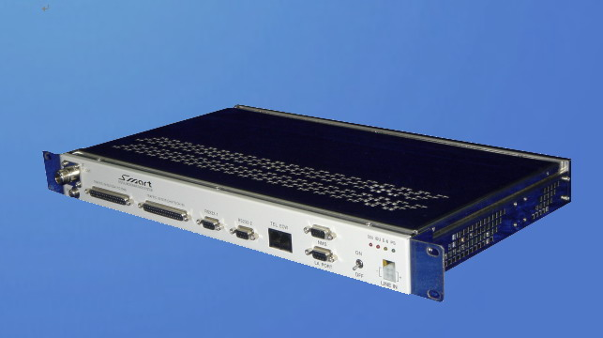

Fig.4.1 IDU outview
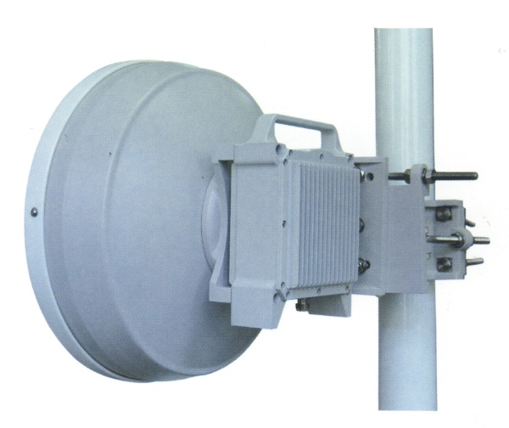

Fig.4.2 antenna and ODU of 1+0 non-protection system

4.2 Chart
4.2.1 ODU
ODU consists of TX unit which includes IF circuit, Up converter, power amplifier and filter, RX unit which integrates LNA, filter, down converter, filter and second down converter, AGC IF amplifier, RF duplexer, IF interface, SV circuit and power distribution.
Block diagram of the ODU is shown in Figure 4.3.

4.2.2 IDU
IDU includes QPSK modulator、QPSK demodulator、demux、IF interface and SV circuit、digital orderwire、power distribution circuit etc..
Block diagram of IDU is shown in Figure 4.4.

Fig.4.3 Block diagram of ODU
IF
DC－DC
SV circuit
RX LO2
AGC IF AMP
DOWN MIX-2
DOWN MIX-1
LNA
UP MIX-1
POR AMP
RF

IN/OUT
IF
IN/OUT
UP MIX-2
TX LO2
TX LO1
RX LO1

Mux and demux
Data processor
QPSK modulator
IF

SV circuit
QPSK demodulator
Power supply
Digital orderwire

Fig.4.4 Block diagram of IDU
Telep-hone
N×E1
IN

N×E1
OUT

TO PC
-48V DC
TO ODU

4.3 Principle
N E1 signals is multiplexed, compound with digital orderwire, auxiliary data and PC communication data, and processed in Data processor into data of specific frame, which is QPSK-modulated with IF carrier and transmitted to ODU. In ODU, upward IF signal is separated to line equalization circuit by duplexer and sent to second-converter, power amplifier, filter, converted and transmitted by antenna. At the opposite station, received signal by antenna is sent to duplexer, LNA-MIX, filter, second converter, turned to 70MHZ IF signal; then IF signal is down transmitted to IDU, QPSK demodulator, frame data is recovered and separated to main stream and other service signals, main stream will be turned to N E1 signals.
SV unit is centrally controlled by CPU, functions signal collection, signals processing, control signal’s generation, transmitting and alarm generation and processing, status indication. And statistics of bit error based

on multiplexer/demultiplexer’s information, forming 1E-3BER、1E-6BER and loss of synchronization of frame. Monitor and control signals can be accessed through PC.
Digital orderwire takes A-law 64kb/s、PCM codec with service channel.

5．Application
5.1 Design Consideration
5.1.1 Network capacity
In case of the N×2Mbit/s system, each I/O port is independent, therefore, the N×2Mbit/s can be connected with any standard signal sources which have HDB-3(ITU-T G.703)2Mbit/s, such as inter-connecting between BTSs in cell network, relaying a 2Mbit/s trunk link or video conference.
5.1.2 Antenna
Digital microwave Smart antenna includes diamter 0.3m to 2m with stable mechanical performance. All series from 0.3m to 2m antenna can be connected to ODU without waveguide, resulting low cost, more safe, fast and easy installation. With pole installation, it’s unnecessary to move antenna and bracket including orientor when changing ODU. Reflector of antenna is covered by white.

5.1.3 Indoor unit（IDU）
IDU is free to frequency band, it can be used at any specified frequency band. IDU takes advanced digital narrowband and equalization, therefore can contain large scale of RX IF level. Height is 1U, and be installed in standard 19” rack. Out view is shown in figure 4.1.

5.1.4 Outdoor Unit（ODU）
ODU is transmitter and receiver, transmitting capacity of 2×E1/4×E1/8×E1/16×E1/1×E3 in 7/8/1113/15GHz frequency band. In specified band, it is free to capacity.
Advanced IC has been used in all ODU, covering RF radio series(power amplifier, LNA, MIX, LO, duplexer etc.).High reliability, suitable for rough climate. Out view is shown in Figure 4.2.

5.1.5 Inter-connection between ODU and IDU
Only one coaxial is used between ODU and IDU, in which TX IF signal(310MHz)、RX IF signal（70MHz）、DC power supply and SV signal are transmitted. Various type of coaxial, maximum length is up to 300m.

5.1.6 Power supply
Nominated voltage is -48VDC, range from -36V to -72V.
5.2 Major customer areas
◆Cell phone subscribers
◆Commercial institution
◆Local government
◆Utilities
◆Emergency services(flood etc.)
◆Transportation（railway、subway etc.）
◆Education（campus network）
◆Martial
◆Port authority
◆Broadcasting
5.3 General applications
◆Telephone services
◆Data transmission
◆Local area network
◆Back-up transmission line
◆Customer services
◆Security control
◆Relay communication
◆Traffic surveillance
◆Remote monitoring
5.4 Specific applications
◆Point-to-point link in buildings
◆Connecting intercompany
◆Access to local exchange station
◆Providing satellite PBX at a separate building
◆Data transmission to the computer center
◆Extension of PBX subscriber lines
◆Transmission link for points separated by water
◆Remote monitoring of parking lots / public areas
◆Emergency back-up links among local authorities
◆Temporary links for facilities under construction
◆Fixed link between mobile base stations
5.5 Application cases
5.5.1 Voice/data service（take 4×E1 for example）
Point-to-point voice or data transmission
IDU
ODU
4×2Mbit/s
IDU
ODU
4×2Mbit/s
PCM
30CH/data
PCM
30CH/data
PCM
30CH/data
PCM
30CH/data
PCM
30CH/data
PCM
30CH/data
PCM
30CH/data
PCM
30CH/data

Fig. 5.1 Voice/data service

5.5.2 Multimedia service（take 4×E1 for example）

IDU
ODU
4×2Mbit/s
IDU
ODU
4×2Mbit/s
PCM
30CH/data
PABX
TEL/FAX DATA

Video
LAN
PCM
30CH/data
PABX
TEL/FAX DATA

Video
LAN
Fig. 5.2 Multimedia services

5.5.3 Mobile communication network
Connection between PSTN and MSC
Connection between MSC and BSC
Connection between BSC and BTS

E3

PSTN
E3

16×E1
2×E1
Smart

MSC
Smart

BSC

BTS

BTS

BSC

BTS

BTS
16×E1
8×E1
2×E1
2×E1
2×E1
2×E1
8×E1
Smart
Smart
Smart
Smart
Smart
Smart
Smart
Smart
Smart
Smart
Smart
Smart
2×E1

2×E1

2×E1

Fig. 5.3 Mobile communication netwrork

